SIMATS ENGINEERING
ASSESSMENT TOOL 1

COURSE NAME: MLA03
COURSE CODE: Reinforcement learning

COURSE OUTCOME COVERED

CO1: Analyze reinforcement learning frameworks and Markov Decision Process concepts to model decision-making problems. (BL2, BL3)

Assessment Tool Weightage: 50%

Dr. G. A. Senthil

QUESTIONS: 10 Total Marks: 50

Annexure A

RL Basic Experiments demo with Keras and TensorFlow using Anaconda navigator

Duration: 2hrs

Experiment 1: Installation of Reinforcement Learning Development Environment

Aim:
To install and configure Anaconda Navigator, Python, TensorFlow, Keras, Gymnasium (OpenAI Gym), NumPy, Matplotlib, and other required libraries, and verify the environment by executing a simple Reinforcement Learning program

Output:

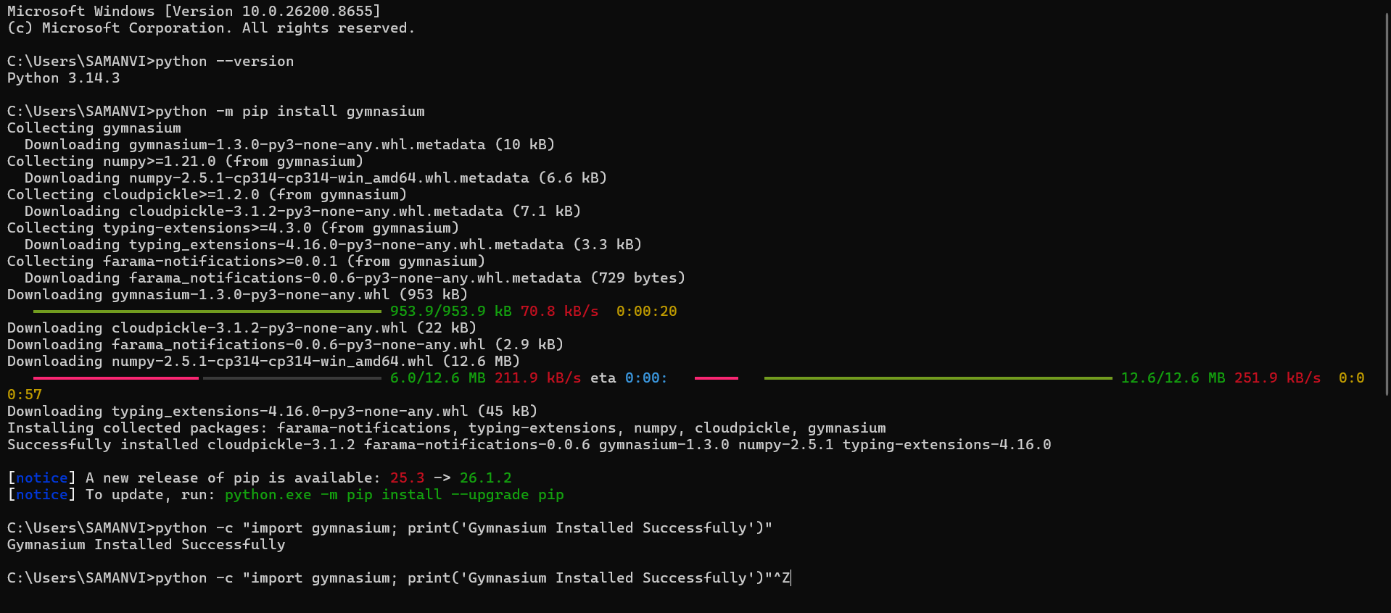

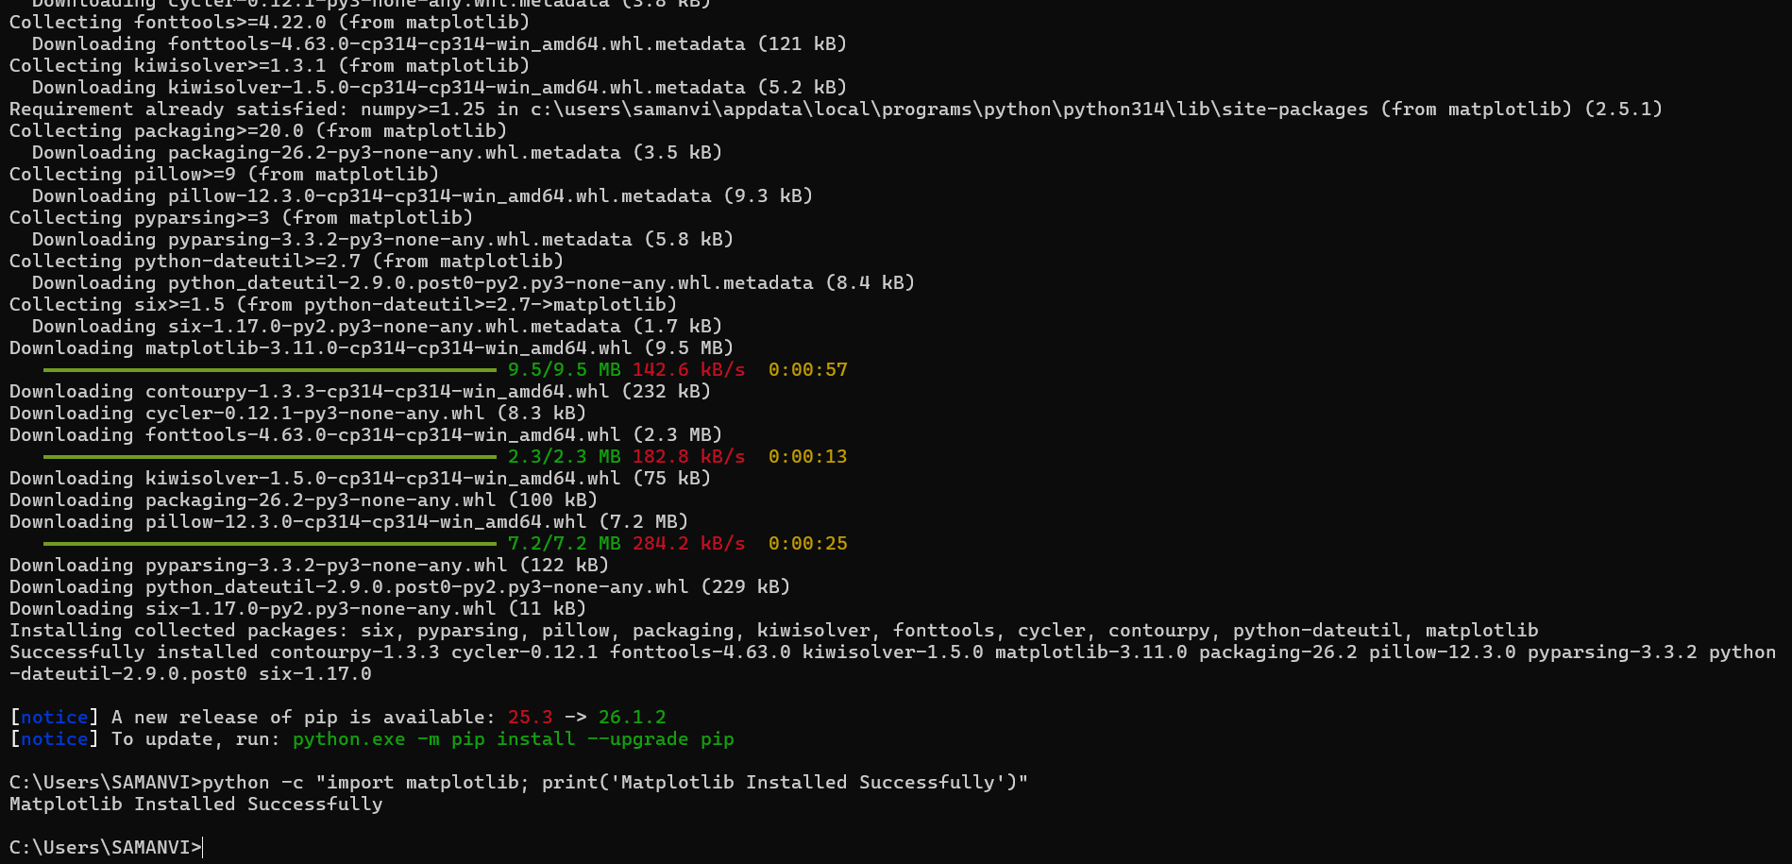

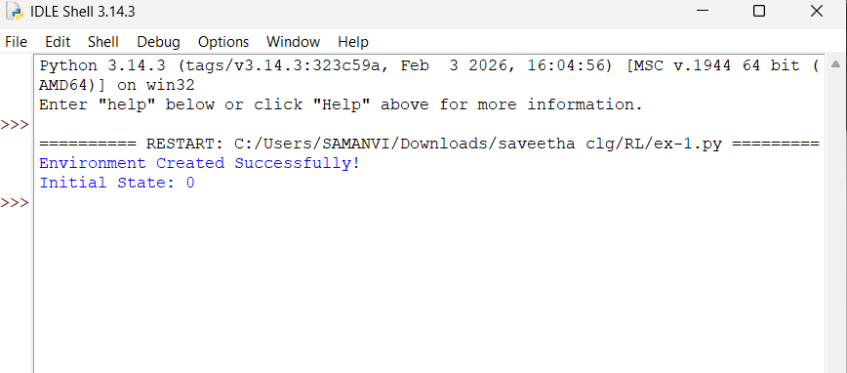

Experiment 2: Familiarization with OpenAI Gym/Gymnasium Environments

AIM: To create, initialize, and interact with the FrozenLake environment to understand states, actions, rewards, and episodes

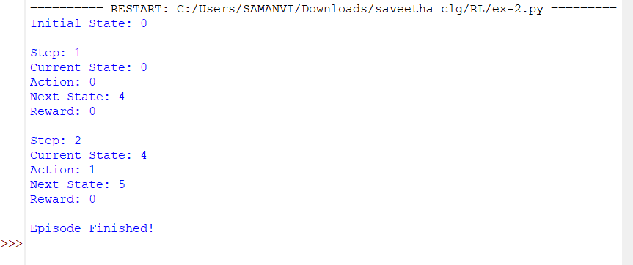
Output:

Experiment 3: Implementation of the Reinforcement Learning Framework

Aim: To implement the basic Reinforcement Learning framework by designing an agent that interacts with an environment through states, actions, rewards, and policies using Python

Output:

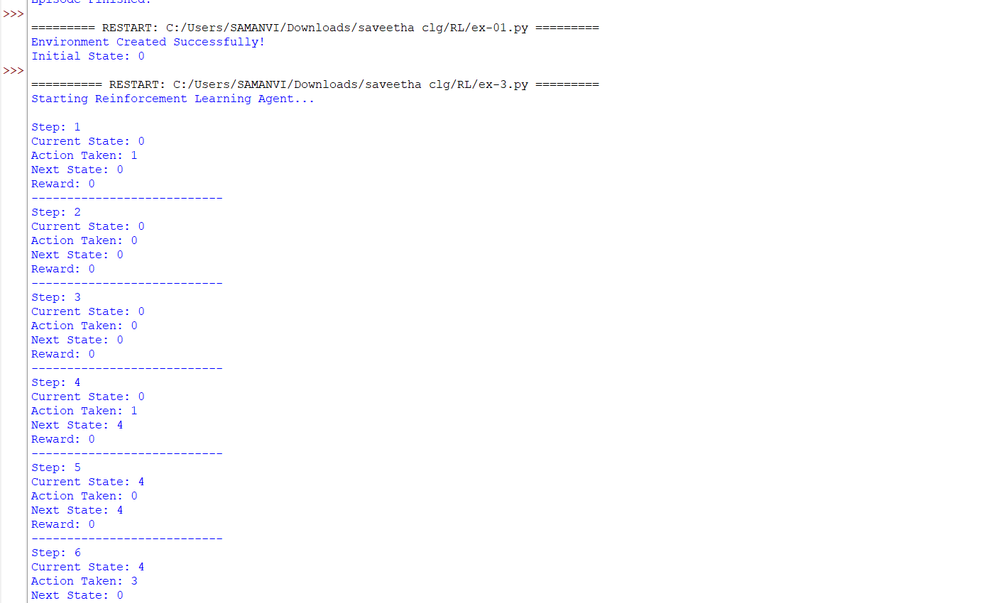

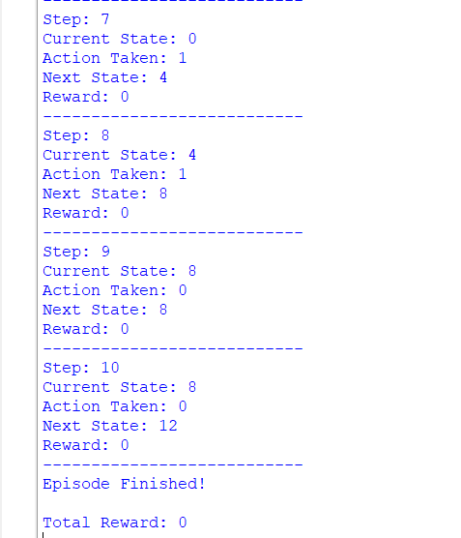

Experiment 4: Simulation of a Markov Decision Process (MDP)

Aim: To develop a simple Markov Decision Process (MDP) model and simulate state transitions, reward functions, and policy execution for understanding sequential decision-making problems

Output:

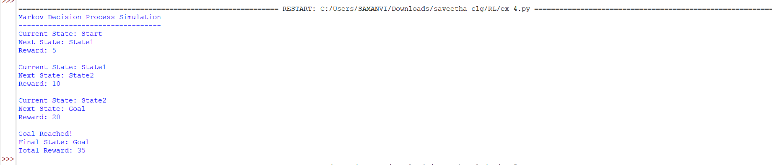

Experiment 5: Bellman Equation Demonstration

Aim: To implement Bellman Expectation and Bellman Optimality Equations for calculating state-value and action-value functions and analyze the convergence of value estimation.

Output:

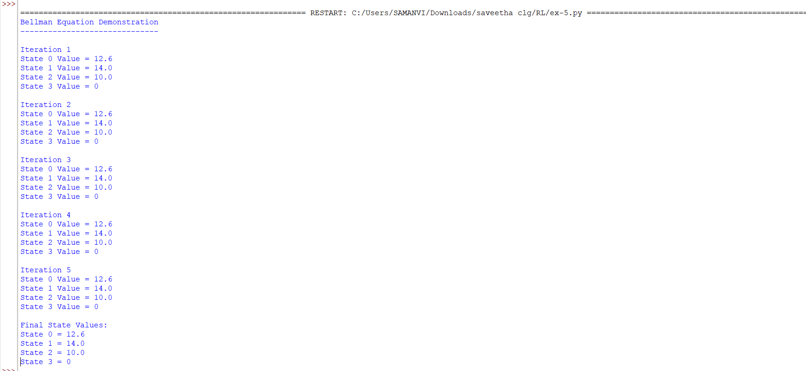

Experiment 6: Exploration vs. Exploitation Strategies

Aim: To implement ε-Greedy, Greedy, and Random action-selection strategies and compare their performance in balancing exploration and exploitation during Reinforcement Learning.

Output:
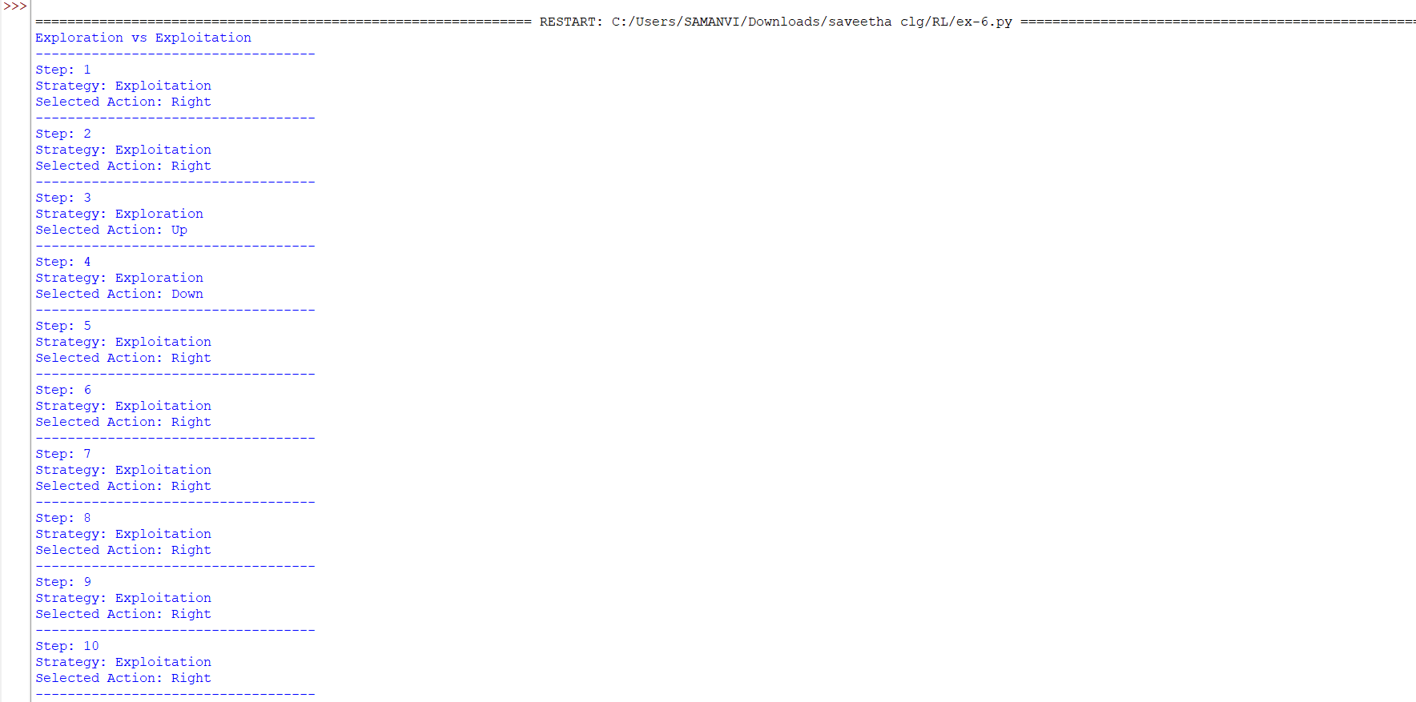

Experiment 7: Multi-Armed Bandit Problem

Aim: To implement the Multi-Armed Bandit problem using ε-Greedy and Upper Confidence Bound (UCB) algorithms and evaluate cumulative rewards obtained by different action-selection methods

Output:

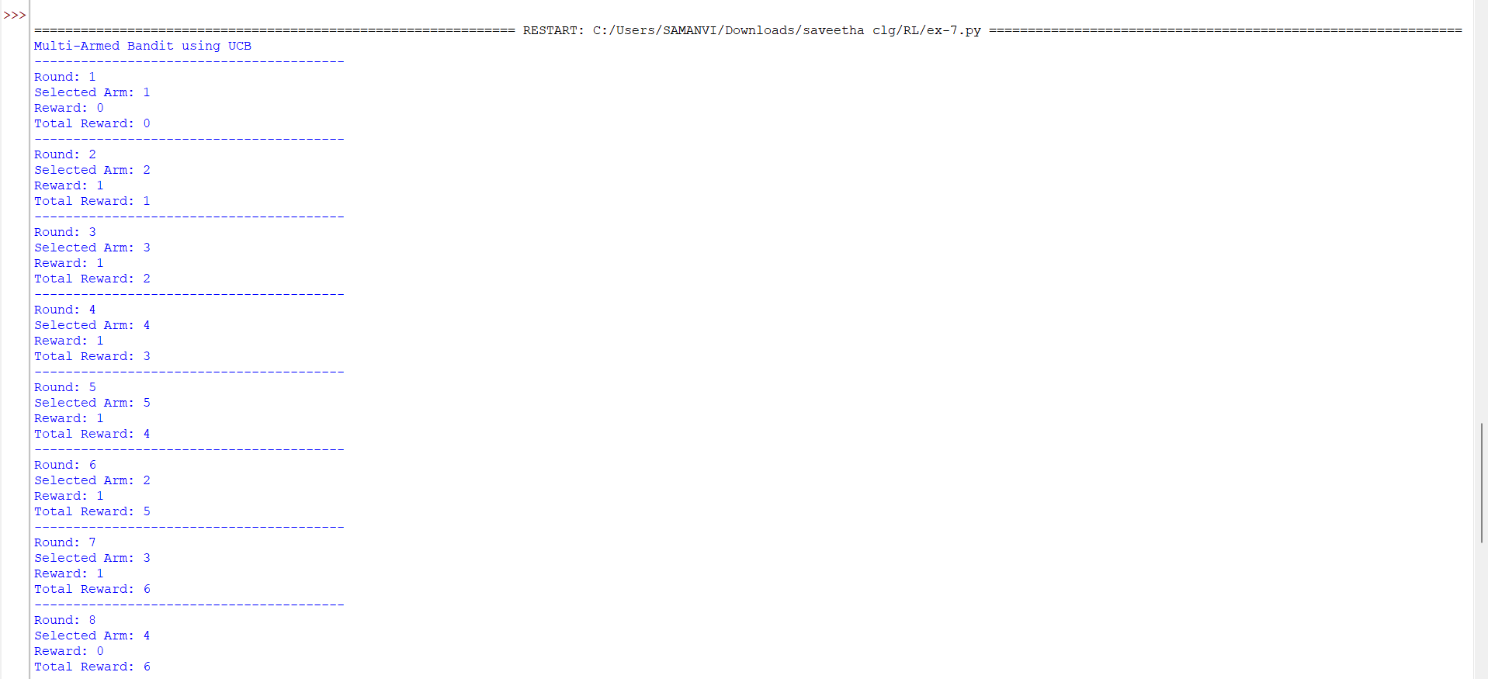

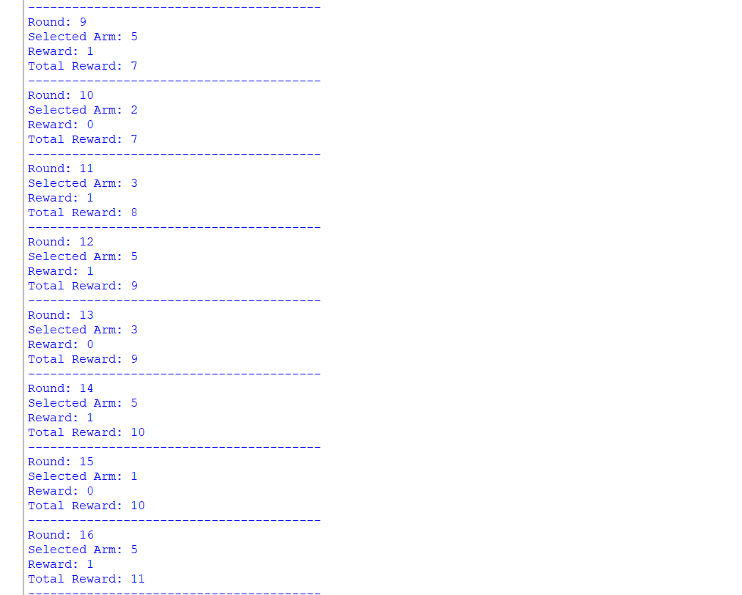

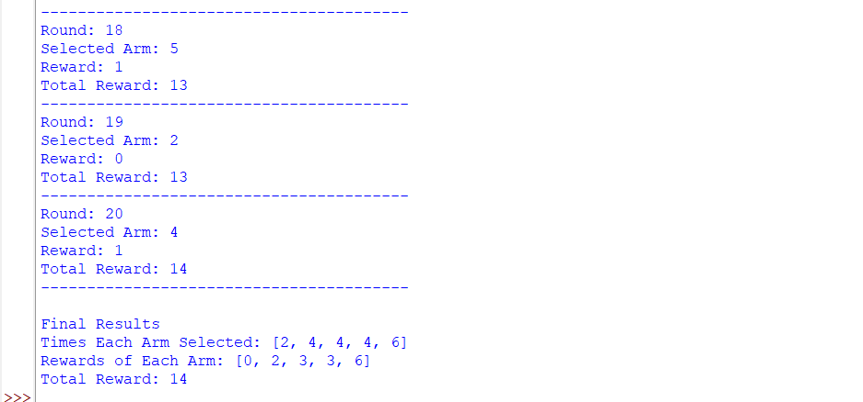

Experiment 8: Reward Visualization in Reinforcement Learning

Aim: To simulate an RL agent in a simple environment and visualize cumulative rewards, episode rewards, and learning performance using Matplotlib graphs

Output:

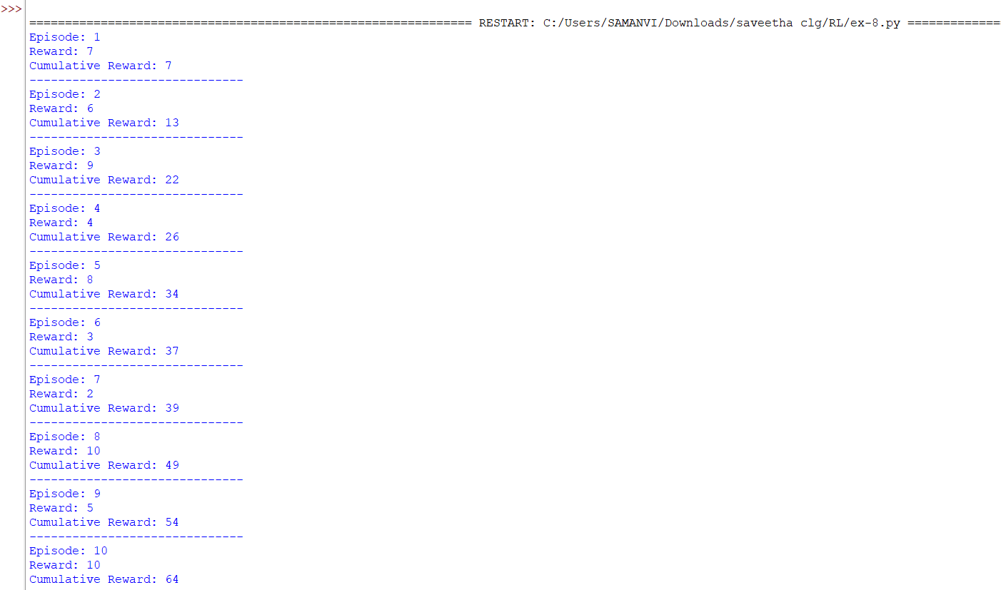

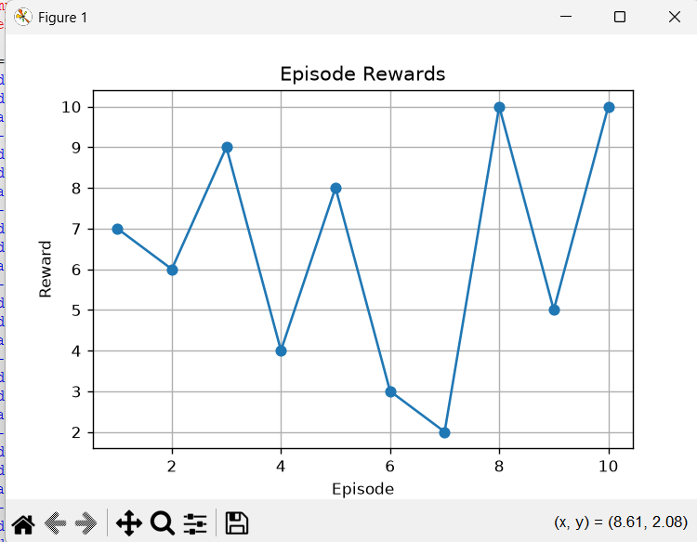
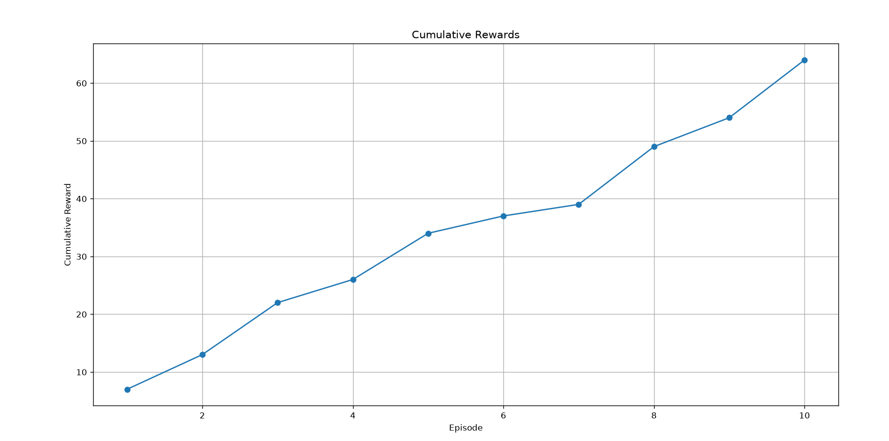

Code of Conduct:

I _M.samanvi(192425318)_____ (Name / Reg No) certify that this submission is my original work and that I have adhered to the guidelines specified for this assessment.
I understand that any violation of academic integrity rules will result in disciplinary action.

Signature of the student: M.samanvi

RUBRICS FOR CALCULATION

Criteria | Weightage | Level 4 – Exemplary | Level 3 – Proficient | Level 2 – Developing | Level 1 – Beginning
Understanding of Concepts | 25% | Demonstrates thorough, accurate understanding of concepts | Good understanding with minor gaps | Basic understanding with some misconceptions | Poor understanding; major misconceptions
Explanation | 25% | Detailed, well-explained answers with relevant examples | Clear explanation with adequate details | Limited explanation; lacks depth | Poor or unclear explanation
Application | 20% | Effectively applies concepts with strong analytical ability | Applies concepts with minor errors | Limited application with weak analysis | No application or incorrect analysis
Organization | 15% | Well-structured answers with logical flow and coherence | Organized with minor issues in flow | Basic structure, lacks clarity | Poor organization, incoherent answers
Accuracy | 10% | Completely accurate and covers all required points | Mostly accurate with minor omissions | Partially correct with missing points | Incorrect answers with major gaps
Clarity | 5% | Clear, neat, professional presentation | Understandable with minor issues | Limited clarity, readability issues | Poorly written, difficult to understand

